CSA1413
COMPILER DESIGN
Name: M Praneeth
Reg No: 192324184
Character Counting

Aim:
To write a LEX program to read a text file and count the number of vowels, consonants, digits, alphabetic characters, uppercase letters, lowercase letters, and special characters, ignoring spaces.

Algorithm:
- Start the program.
- Include the required header files and initialize all counters to zero.
- Open the input text file and check whether it is opened successfully.
- Read the file character by character using LEX.
- Count vowels, consonants, digits, alphabetic characters, uppercase letters, lowercase letters, and special characters separately.
- Ignore spaces, tabs, and newline characters.
- Display all the calculated counts.
- Close the file and stop the program.

Pseudocode:
BEGIN
Initialize all counters to 0
Open the input text file
IF file opening fails THEN
Print error message
EXIT
END IF
Read the file using yylex()
FOR each character DO
IF character is a vowel THEN
Increment vowel count
ELSE IF character is an alphabetic character THEN
Increment consonant count
END IF
IF character is alphabetic THEN
Increment alphabetic count
END IF
IF character is uppercase THEN
Increment uppercase count
ELSE IF character is lowercase THEN
Increment lowercase count
END IF
IF character is a digit THEN
Increment digit count
ELSE IF character is a special character THEN
Increment special character count
END IF
Ignore spaces, tabs, and newlines
END FOR
Display all counters
Close the file
END

Code:
%{
#include <stdio.h>
int vowels = 0, consonants = 0;
int digits = 0, alphabets = 0;
int uppercase = 0, lowercase = 0;
int special = 0;
%}
%option noyywrap
%%
[AEIOU] {
vowels++;
alphabets++;
uppercase++;
}
[aeiou] {
vowels++;
alphabets++;
lowercase++;
}
[A-Z] {
consonants++;
alphabets++;
uppercase++;
}
[a-z] {
consonants++;
alphabets++;
lowercase++;
}
[0-9] { digits++; }
[ \t\n]+ ;
. { special++; }%%
int main(int argc, char *argv[])
{
if (argc != 2)
{
printf("Usage: %s input.txt\n", argv[0]);
return 1;
}
yyin = fopen(argv[1], "r");
if (yyin == NULL)
{
printf("Error opening input file!\n");
return 1;
}
yylex();
printf("\nVowels: %d\n", vowels);
printf("Consonants: %d\n", consonants);
printf("Digits: %d\n", digits);
printf("Alphabetic characters: %d\n", alphabets);
printf("Uppercase letters: %d\n", uppercase);
printf("Lowercase letters: %d\n", lowercase);
printf("Special characters: %d\n", special);
fclose(yyin);
return 0;
}

Input:
Hello LEX
world
Student_123
class2026
Output:
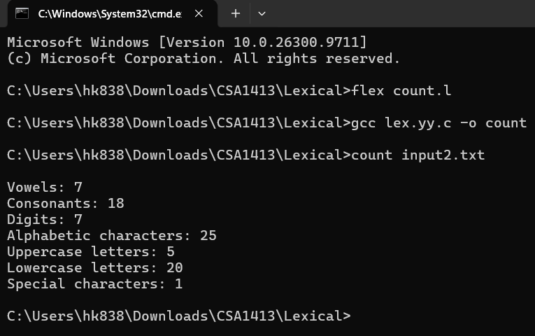

Result:
Thus, the LEX program to count vowels, consonants, digits, alphabetic characters, uppercase letters, lowercase letters, and special characters while ignoring whitespace was executed successfully.

